FINAL PROJECT REPORT
on
SMART PARKING SLOT ALLOCATOR
Greedy Allocation, Binary Search and Priority Queue
Submitted by
Student Name | Roll Number
[Student 1 name] | [Roll no.]
[Student 2 name] | [Roll no.]
[Student 3 name] | [Roll no.]
[Student 4 name] | [Roll no.]

Department of [Department Name]
[College Name], [City]
Under the guidance of
[Guide Name], [Designation]
Academic Year: [20XX – 20XX]

2. Abstract and Introduction

2.1 Abstract
Finding a free parking space wastes time and fuel, and the problem grows when bikes, cars and large vehicles, and drivers with different priorities, compete for the same lot. This project presents the Smart Parking Slot Allocator, an interactive prototype that assigns slots by vehicle size, distance from the entrance, availability and priority.
A greedy rule chooses the smallest slot size that fits and the free slot nearest the requested distance. Binary search on a distance-sorted list of free slots finds that slot in O(log n) steps. A binary max-heap priority queue holds vehicles that cannot be parked yet and serves them by urgency (Emergency, Disabled, VIP, Regular) when a slot is released. The HTML/CSS/JavaScript dashboard shows free and occupied slots and explains every decision. All 12 logic tests passed, and binary search needed about 17 comparisons on 100,000 slots against about 50,000 for a linear scan.
Keywords: parking allocation, greedy algorithm, binary search, priority queue, binary heap.

2.2 Problem Background
In malls, hospitals, offices and campuses, drivers circle the lot, small vehicles take large slots, and priority users may not find a nearby space. Manual allocation does not scale, and scanning every slot for each request becomes slow in large lots.

2.3 Proposed Solution and Purpose
Free slots are kept in one distance-sorted list per size class. A greedy rule selects the size class, binary search selects the slot, and the dashboard highlights the suggestion. If nothing fits, the vehicle waits in a priority queue. The purpose is to apply Greedy, Binary Search and Priority Queue algorithms to one connected problem and to make their decisions easy to understand.

3. Problem Statement, Objectives and Scope

3.1 Problem Statement
Design a system that allocates parking slots based on vehicle size, distance, availability and priority, quickly finds suitable free slots, shows which slots are free or occupied, and automatically suggests a slot.

3.2 Objectives
- Represent the lot with a suitable data structure (slot size, distance, occupancy).
- Allocate slots with a clear greedy rule that minimises the distance gap.
- Use binary search on sorted data and report the number of comparisons.
- Serve waiting vehicles with a priority queue that has explicit criteria.
- Show the objective value and a trace that explains each decision.

3.3 Scope
In scope: one lot of 30 slots (6 Small, 18 Medium, 6 Large), three vehicle types, four priority levels, slot suggestion, release and waiting queue, and algorithm trace panels. Out of scope: persistent storage, user accounts, payment, sensors and multiple floors (see Future Enhancements).

3.4 Target Users
Parking attendants, drivers, facility managers, and students or evaluators studying the algorithms.

4. Features and Functional Requirements

4.1 Main Features and User Functionalities
- Live slot map with Free and Occupied slots, labelled with ID, size and distance.
- Automatic slot suggestion, highlighted before the user confirms.
- VIP, Disabled and Emergency vehicles target the nearest slot (0 m).
- Priority queue served automatically when a slot is released.
- Explanation panels (greedy choice, binary search steps, heap, history) and metrics (total distance gap, binary versus linear comparisons).
- Release a slot by clicking it.

4.2 CRUD Operations
Operation | Implementation
Create | Park a vehicle or add it to the waiting queue
Read | View slot status, queue, history and metrics
Update | Queue moves a waiting vehicle into a freed slot
Delete | Release a slot and return it to its sorted free list

4.3 Authentication and Validation
The prototype has no login because it is a single-user demonstration. Validation rejects an empty plate number and a plate that is already parked or waiting; vehicle type, priority and the 0–60 m distance are limited to fixed choices. Authentication is listed as future work.

4.4 System Requirements
Any device with a current web browser (Chrome, Edge, Firefox or Safari). No installation or network is needed; the HTML file is simply opened in the browser.

5. Algorithms and Methodology

5.1 System Workflow
- The user enters plate, vehicle type, priority and preferred distance, then clicks Suggest slot.
- Target distance is the preferred value, or 0 m for VIP, Disabled and Emergency vehicles.
- The greedy rule checks size classes from smallest to largest, skipping those too small or full.
- Binary search on that class finds the first slot at or beyond the target; the closer of it and its neighbour wins.
- The user confirms and the slot is marked occupied; if no slot fits, the vehicle joins the priority queue.
- On release, the slot returns to its sorted list and the most urgent waiting vehicle is popped and allocated.

5.2 Algorithms Used
Greedy. For each arrival, choose the smallest sufficient size (best fit), then the free slot with the smallest |slot distance − target|; ties go to the nearer slot. This keeps large slots free for large vehicles. The objective is to minimise the total distance gap. The choice is fast and explainable but not claimed to be globally optimal.
Binary search. Each free list is sorted by distance. A lower-bound search finds the first distance ≥ target, halving the interval each step, and the dashboard records lo, hi, mid and the comparison count.
Priority queue. A binary max-heap orders waiting vehicles by priority (Emergency 4, Disabled 3, VIP 2, Regular 1), then by earliest arrival.
Algorithm | Role | Complexity
Greedy best fit | Chooses size class and slot | O(1) class checks
Binary search | Finds slot nearest target | O(log n)
Max-heap | Orders waiting vehicles | O(log m) per push or pop
Sorted insert on release | Keeps free lists ordered | O(log n) search + O(n) shift

The sorted insert costs O(n) in the worst case because a JavaScript array shifts elements; a balanced search tree would make it O(log n).

5.3 Development Methodology and Data Flow
An incremental prototype approach was used: core algorithms first, then the slot map, then the explanation panels and metrics, with automated tests on the core logic. Data flows from the vehicle request, through input validation and the greedy and binary search steps, to either the slot allocation (updating the map, history and metrics) or the priority queue; a release feeds back into the sorted lists and the queue.

6. Technologies and Implementation
Area | Used
Frontend | HTML5, CSS3 (grid, flexbox), JavaScript ES6, no external libraries
Backend | None; all logic runs in the browser
Database | None; data is held in memory and resets on reload
Tools | Web browser, VS Code, Node.js (testing and benchmarks)

6.1 Implementation Details
Each slot is an object with ID (A1 to C10), size, distance and the vehicle parked in it. Distance is column × 6 + row × 2 + 3 metres (3 m to 61 m); columns 1–2 are Small, 3–8 Medium and 9–10 Large. Free slots are stored in three sorted arrays, one per size.
Key functions: lowerBound (binary search with step recording), findSlot (greedy rule returning a full trace), PriorityQueue (push and pop on a heap), and park, release and serveQueue. The trace feeds the Greedy, Binary search and History panels, which appear after the first decision.

7. Results, Testing and Performance

7.1 Results
The prototype meets all objectives: it suggests a suitable slot, shows free and occupied slots, explains the greedy choice and binary search steps, serves a priority queue with explicit criteria, and reports the objective value and comparison counts. Priority vehicles get the slots nearest the entrance.

7.2 Test Cases and Methods
Unit, boundary and scenario tests were run with Node.js on the dashboard's core logic; the dashboard itself is checked manually in a browser.
ID | Test case | Expected result | Status
TC1 | Binary search incl. empty list and out-of-range targets | Correct indices | Pass
TC2 | Heap pop order for mixed priorities and arrival times | Highest priority, then earliest | Pass
TC3 | Free lists stay sorted by distance | Non-decreasing | Pass
TC4 | Car, preferred distance 0 m | Nearest Medium slot (A3) | Pass
TC5 | Bike request | Small slot | Pass
TC6 | Car, preferred distance 30 m | Minimum possible gap | Pass
TC7 | VIP with preferred distance 50 m | Target overridden to 0 m | Pass
TC8 | SUV request | Large slot only | Pass
TC9 | Park a vehicle | Removed from free list | Pass
TC10 | Bike when Small slots are full | Falls back to Medium | Pass
TC11 | Fill Large slots, queue Regular, Emergency and VIP SUVs, release one | Emergency vehicle gets the slot | Pass
TC12 | No slot assigned twice | All plates unique | Pass

7.3 Performance Analysis
For 2,000 random targets in sorted lists of each size, the average number of comparisons was recorded (values from an actual run).
Free slots (n) | Binary search | Linear scan
30 | 5.0 | 16.8
100 | 6.7 | 52.0
1,000 | 10.0 | 502.3
10,000 | 13.4 | 4,907.4
100,000 | 16.7 | 50,153.1

Binary search grows with log2(n) while a linear scan grows with n. The heap handled 100,000 push and pop operations in about 165 ms (machine dependent).

7.4 Screenshots and Output
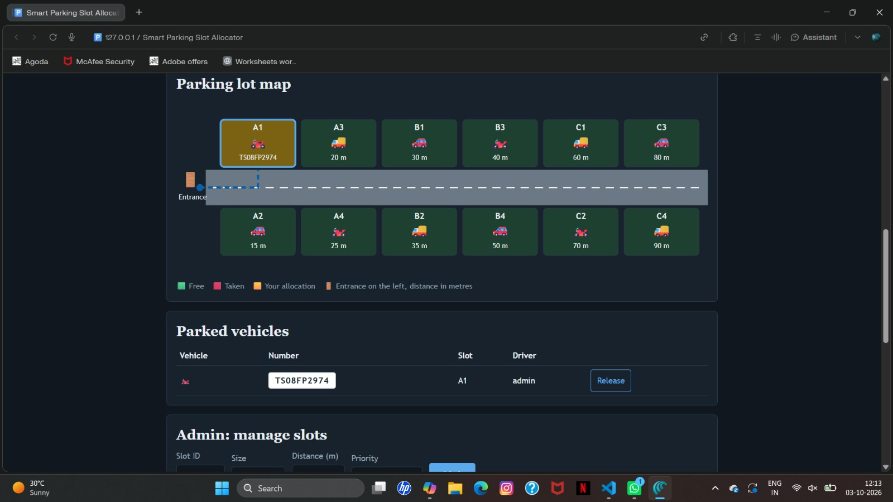
Figure 1: Dashboard on start-up
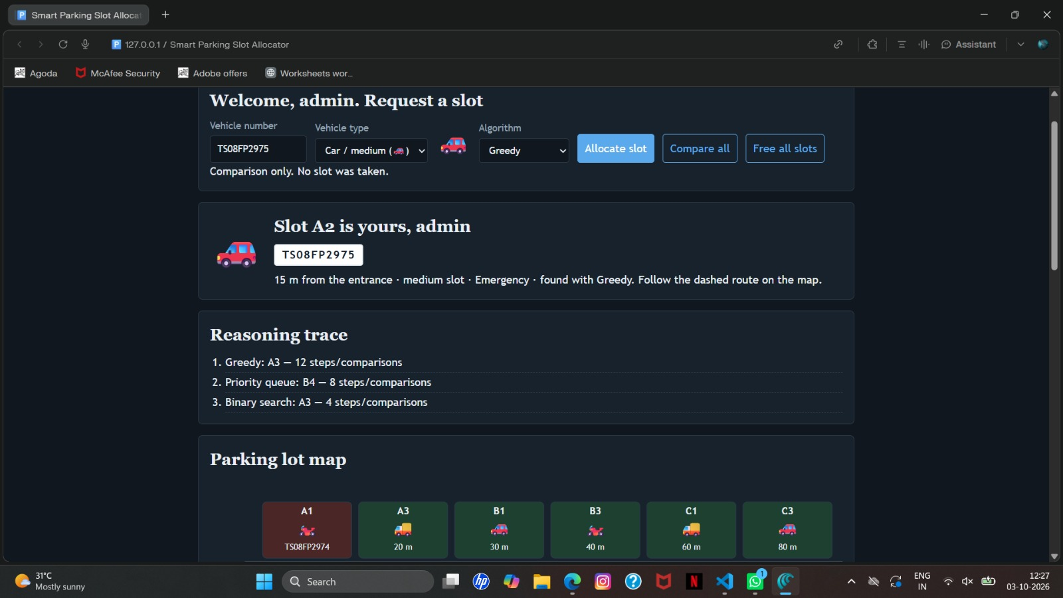
Figure 2: Slot suggestion with decision trace
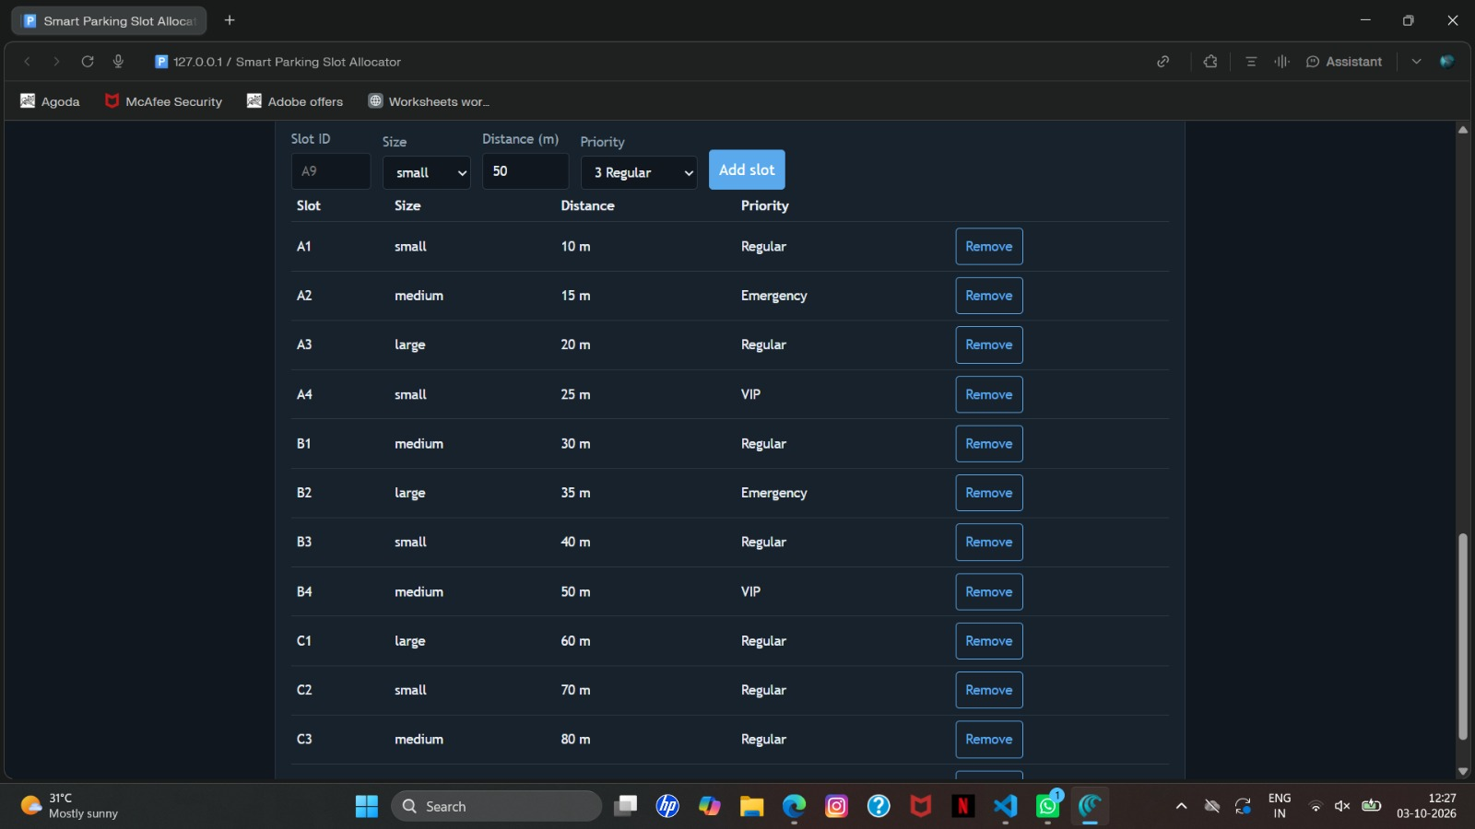
Figure 3: Queue, history and objective value

8. Conclusion and Future Scope

8.1 Conclusion
The Smart Parking Slot Allocator combines greedy allocation, binary search and a priority queue to solve a practical problem and to make each decision visible. Greedy allocation is fast and explainable, binary search keeps lookup efficient as the lot grows, and the priority queue serves urgent vehicles first. The core logic passed all 12 tests. The prototype is limited to one lot with in-memory data, but it is a clear base for a full system.

8.2 Future Enhancements
- Database and REST backend for persistent data.
- Authentication with operator and driver roles.
- Multiple floors, reservations, parking time and fee calculation.
- Balanced search tree so slot insertion is also O(log n).
- Sensor or camera integration and a mobile app with navigation.

9. References and Documentation

References
- T. H. Cormen, C. E. Leiserson, R. L. Rivest and C. Stein, Introduction to Algorithms, 3rd ed., MIT Press, 2009.
- S. Dasgupta, C. Papadimitriou and U. Vazirani, Algorithms, McGraw-Hill, 2008.
- R. Sedgewick and K. Wayne, Algorithms, 4th ed., Addison-Wesley, 2011.

Documentation
- MDN Web Docs: HTML, CSS and JavaScript reference, developer.mozilla.org.
- Node.js documentation, nodejs.org (used for testing and benchmarks).
- Project source code: smart-parking-v2.html (single-file dashboard).

